**79483499**

Base URL:

**https://www.voplit.com**

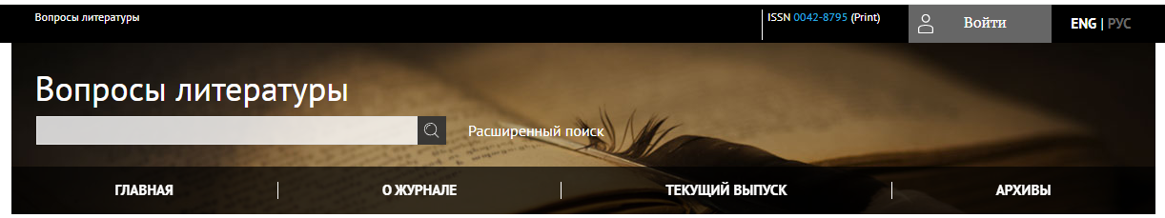

**First translate the web site from here.**

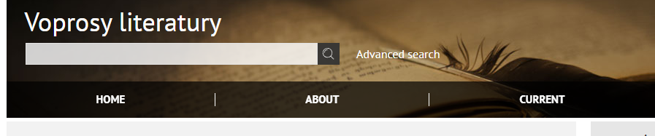

**Select the Current issue from here.**

* Meta data can be captured as below.

**Issue and Year**

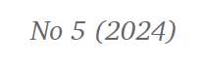

**Page Range**

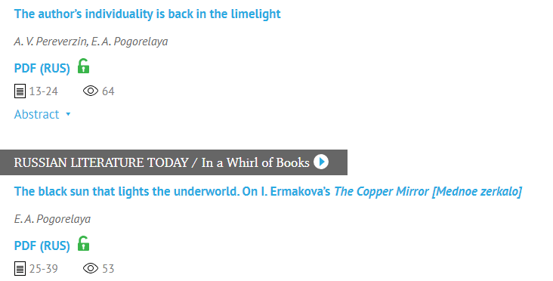

**Article Name**

**Page range**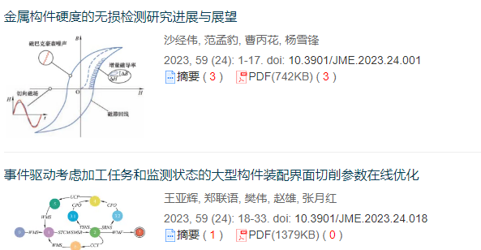

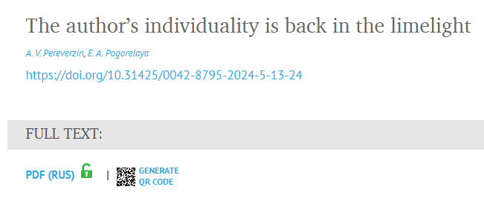

**DOI**

**Click here to download the pdf**

* In here Russian toc needs to be captured so choose language option from website language conversion . then go to the Table of content page right click and save as pdf.